Mike Sherman

3/22/2017  Z: 23353292

Programming Assignment Report

**Table of Contents**

*Introduction…………………………………………………………………………………………………1*

*General Logic Flowchart …………………………………………………………………………………1*

*Results………………………………………………………………………………………………………..2*

*Discussion……………………………………………………………………………………………………2*

*Program Output……………………………………………………………………………………………..3*

*Source Code………………………………………………………………………………………………….4*

**Introduction**

This program simulates a CPU scheduler using three different algorithms; first come first serve (FCFS), shortest job first (SJF), and multilevel feedback queue (MLFQ). The first two algorithms are non-preemptive, and MLFQ is preemptive in the sense that once a process from a higher priority queue finishes an I/O burst, it preempts any process from a lower priority queue that has control of the CPU.

I was unable to complete the MLFQ implementation, so I will be focusing on the first two scheduling algorithms in this report.

**General Logic for FCFS Implementation**

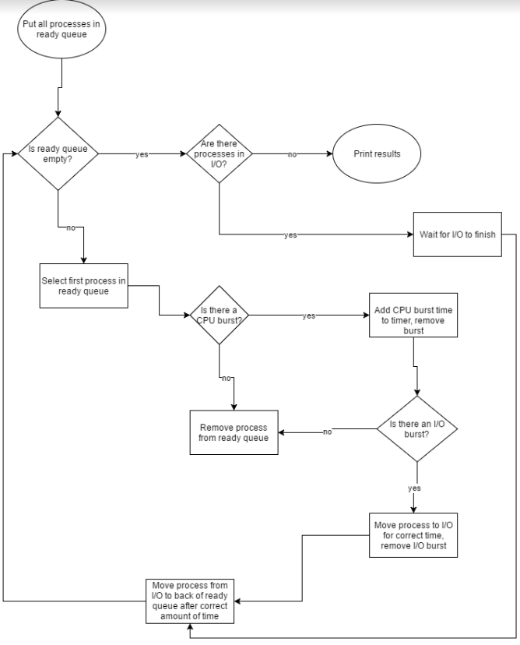

**Results**

|  |  |  |  |
| --- | --- | --- | --- |
|  | **SJF** | **FCFS** | **MLFQ** |
| CPU utilization | 86.43% | 86.03% |  |
| Avg Wait time (WT) | 128.00 | 247.25 |  |
| Avg Turnaround time (TT) | 574.50 | 694.50 |  |
| Avg Response time (RT) | 81.88 | 36.25 |  |

|  |  |  |  |  |  |  |  |  |  |  |  |  |
| --- | --- | --- | --- | --- | --- | --- | --- | --- | --- | --- | --- | --- |
|  | **SJF CPU utilization:**  86.43% | | | | **FCFS CPU utilization:**  86.03% | | | | **MLFQ CPU utilization:** | | | |
|  | ***WT*** | ***TT*** | ***RT*** |  | ***WT*** | ***TT*** | ***RT*** |  | ***WT*** | ***TT*** | ***RT*** |  |
| P1 | 4 | 394 | 0 | 273 | 670 | 0 |  |  |  |
| P2 | 184 | 712 | 81 | 223 | 758 | 4 |  |  |  |
| P3 | 24 | 288 | 9 | 341 | 631 | 22 |  |  |  |
| P4 | 211 | 771 | 45 | 186 | 744 | 28 |  |  |  |
| P5 | 4 | 698 | 4 | 203 | 859 | 45 |  |  |  |
| P6 | 54 | 405 | 15 | 282 | 609 | 50 |  |  |  |
| P7 | 476 | 855 | 476 | 182 | 594 | 60 |  |  |  |
| P8 | 67 | 473 | 25 | 288 | 691 | 81 |  |  |  |
| Avg | ***128*** | ***574.5*** | ***81.88*** | ***247.25*** | ***694.5*** | ***36.25*** |  |  |  |

**Discussion**

As expected, FCFS had much higher average wait time than SJF. However, it is interesting to note how similar the CPU utilization is for both algorithms. I expected FCFS to have lower CPU utilization, due to its simple and unoptimized nature. It is also interesting, but not surprising, that FCFS has such a smaller average response time than SJF. This is not surprising since the first processes to arrive are the first to execute, so it takes less time for the CPU to respond to a request by the very nature of the algorithm. In a time sharing system, it may make more sense to use a FCFS scheduler rather than SJF scheduler, to ensure that all users get good service.

**Program Output (Results and Sample of Dynamic Execution)**

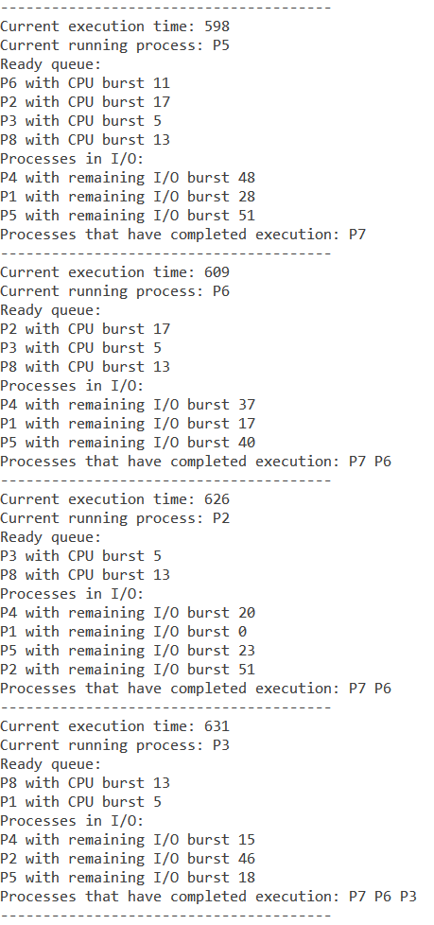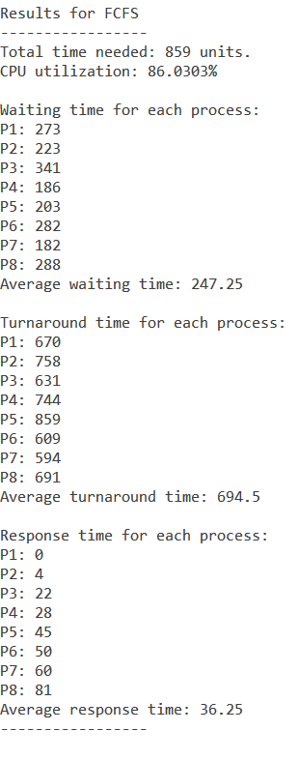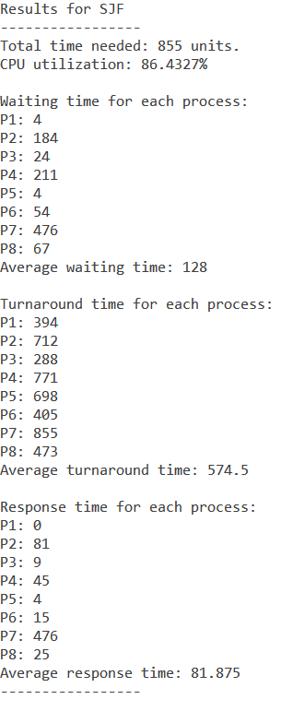*Sample of Execution Results*